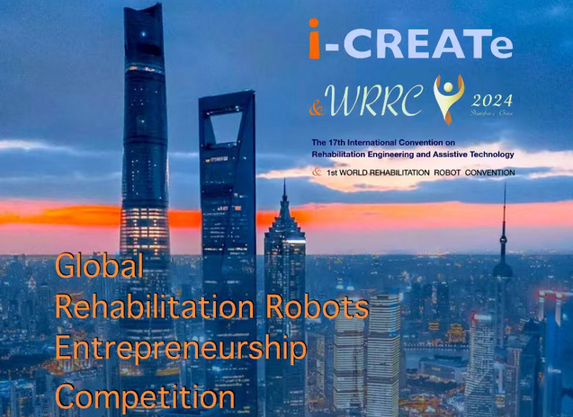

|  |
| --- |
| Global Rehabilitation Robots Entrepreneurship Competition |
| ENTRY FORM |

**ORGANIZED BY:**



**Entry Number:**

**(Official use only)**

**1.Title of the Project**

**1.项目名称**

**2.Particulars of** **Applicant**

**2.申请人详情**

**2.1. Particulars of other team members**

**2.1. 其他团队成员的详细信息**

***\*Please enter name(s) in full [no nicknames as name(s) will be use for certificate and documentation].***

*请完整输入姓名[没有昵称，因为姓名将用于证书和文件]。

**3.Categories**

**3.类别**

Please tick on one of the following请勾选以下其中一项

|  |  |
| --- | --- |
| ☐ Rehabilitation robot technology康复机器人技术 | ☐ Application scenarios of rehabilitation robot康复机器人应用 |

**Project Description**

**4.项目说明**

Give a brief description of your project: Objectives of the project. Who are the target users? Why does the user need this? Have the users been consulted? Feature design or technologies used, safety precaution, etc. You may also include some pictures or illustration of your project. ***(*Please try not to exceed 1000 words****)*

简要描述一下你的项目：项目目标。目标用户是谁？为什么用户需要这个？是否咨询过用户？使用的功能设计或技术、安全预防措施等。您还可以附上一些项目的图片或插图。（*请尽量不要超过1000个字）

**5.Additional Information about the Project**

**5.项目的附加信息**

Has your Project been submitted to any other competition or won any award? If yes, please provide details.您的项目是否已提交给任何其他竞赛或获得任何奖项？如果是，请提供详细信息。

Other points or aspects that you would like to highlight, if any.您想强调的其他要点或方面（如果有的话）。

Has your Project been patent? If yes, please provide details.您的项目是否已获得专利？如果是，请提供详细信息。

**6.Abstract**

**6.摘要**

Please write a short summary of the overall Project and should not exceed 200 words.请写一份关于整个项目的简短摘要，不应超过200字。

**7.Notice**

**7.通知**

The submitted registration materials should be in compressed file and should include the following content:

1. Fill out the complete Entry form GRREC-2024 file;

2. Proof that you are team members.

提交的注册材料应为压缩文件，并应包括以下内容：

1. 填写完整的报名表GRREC-2024文件；
2. 证明你是团队成员。